CMM 275
Asian Perspectives of the Self
TF 12:30-1:45pm| Fall 2024| Prof Mark

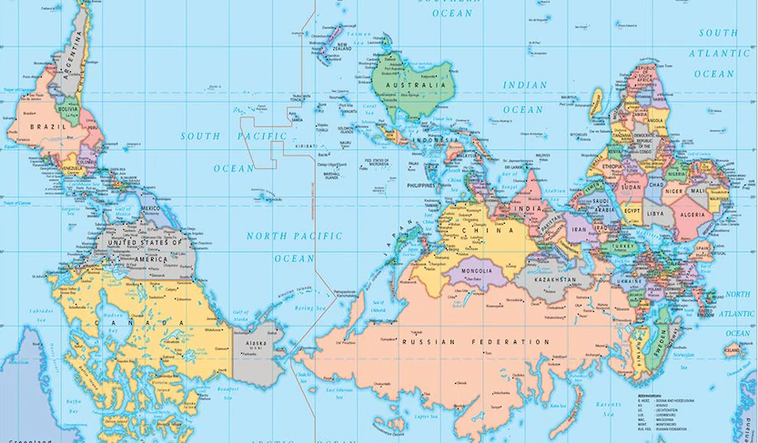

The self emerges from life – the world as grounding, not the human as grounding substance (Colebrook, 2014). Theory begins with the world.

This course invites students to examine how our cultural norms such as our native language(s) and cultural expectations influence our perception and orientations toward one another. We will explore how to create opportunities for connection and mutual respect while communicating across cultures, drawing from relational dynamics from multiple Asian traditions, beginning our exploration with Chinese philosophers. By moving through intercultural communication in these ways, we will strive to expand our toolbox of interpersonal skills through conceptual and discursive knowing, via reflection journals, personal research, and partnered teaching.

Professor Mark brings her experience as a bi-cultural educator, non-profit co-founder, and translator/interpreter in Taiwan and Israel to her scholarship in Intercultural Communication, offering an exploration of practical experience and theory.

